**Poster Making 101** 

When creating a poster you want to achieve three main goals: readability, simplicity, and good design.

**TEXT:**

* Limit your text: 1/3 text to 2/3 visuals, keep information brief.
* Use no more than 2 font types and 4 font sizes. Most important text should be the largest.
* Keep lettering design simple, fancy lettering can be difficult to read.
* To emphasize use all capitals or underline. Remember lower case lettering is easier to read.
* Keep all letters in the same word or phrase the same color and pattern.
* Plan lettering so it fits correctly and looks neat and consistent.
* Lettering should be able to be read from 10-15 feet.

**DESIGN:**

* Focus interest on one idea and make it readable at a glance, don’t overcrowd the poster.
* Stay away from the bulls-eye syndrome! Do not put focus in the center of the poster.
* Choose an image or two that relates to the purpose of the poster, carry on only one idea.
* The larger the item the more it will be seen from a distance.
* Add real items for interest.

**COLOR:**

* Don’t go crazy on color: Color theory works!
* Yellow, Red, Orange can be read at the greatest distance. (Yellow needs a dark outline.)
* Contrast creates interest: dark items on light background or vice versa, complementary colors.
* Use colors that are closely related. Two colors and a neutral provide for one of the two colors to dominate and the other to serve as an accent.
* All letters in a group should be the same color.

**When your poster is complete hang it in a place with the highest traffic for your target audience!**

**Letter Size for Visibility**

|  |  |  |
| --- | --- | --- |
| **Distance** | **Letter Size** | **Line Thickness** |
| 10 feet | ½ inch | 3/32 inch |
| 20 feet | ¾ inch | 1/8 inch |
| 50 feet | 2 inches | 5/16 inch |
| 100 feet | 3 ½ inches | 11/16 inch |
| 300 feet | 11 inches | 2 inches |

**Color Combinations for Visibility**

|  |  |  |
| --- | --- | --- |
| 1. Black on Yellow | 11. White on Green | 21. Purple on Orange |
| 2. Black on Orange | 12. White on Red | 22. White on Green |
| 3. Yellow-Orange on Navy Blue | 13. White on Purple | 23. Green on Yellow |
| 4. Green on White | 14. Purple on White | 24. Red on Orange |
| 5. Red on White | 15. Navy on Yellow | 25. Blue-Green on White |
| 6. Black on White | 16. Navy Blue on Orange | 26. Yellow on Purple |
| 7. Navy Blue on White | 17. Yellow on Black | 27. Orange on Purple |
| 8. White on Navy Blue | 18. Red on Yellow | 28. Green on Orange |
| 9. Yellow-Orange on Black | 19. Yellow on Navy Blue | 29. Blue-Green on Yellow |
| 10. White on Black | 20. Purple on Yellow | 30. Orange on Yellow |

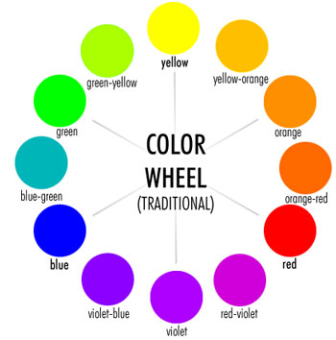

A color wheel organizes the colors of the light spectrum into a circle to make combinations of colors that work well together.

**Monochromatic:** One color plus that color with white or black added to it.

**Analagous:** Three or four colors next to each other on the color wheel.

**Complementary:** Two opposite colors.

**Triad:** Three colors all the same distance apart on the color wheel. Like Red, Yellow, & Blue or Purple, Orange & Green.

**Warm colors:** Reds, yellows, oranges

**Cool colors:** Blues, purples, greens